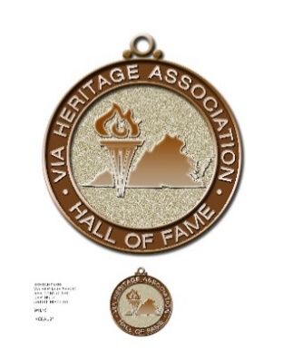

When: Friday, June 24, 2022 – Meet & Greet at 4:00 PM

Where: Charlottesville Double Tree Hotel

Who: Everyone is invited, by making reservations now!

Why: We will honor 7 members of the 6th class of the VIA Heritage Association Hall of Fame

**Note: Program will begin promptly at 5:30 PM**

Make plans now to join us for this special event. Below is a reservation form you can complete and return to the VIA. We look forward to seeing you at the Hall of Fame Banquet on June 24, 2022. The deadline for submitting your reservation is June 1, 2022. Please note that Pre-Purchased tickets will be available at the door. Tickets will not be available for purchase at the door.

***Hotel Reservations***

Those attending the Hall of fame Banquet who want accommodations will be responsible for making their own arrangements. Listed below are several Hotels in the area. Please feel free to contact any of these hotels for rate information and / or reservations.

Doubletree Hotel: 434-973-2121

Holiday Inn University: 434-977-7700

Hampton Inn: 434-978-7888

**Ticket Order Form**

Name: __________________________________________________________________________

Total Number of Tickets: ___________ ($50 each) Please enclose check or money order for the appropriate amount

Seating at reserved HOF Table: Yes/No - (You are welcome to sit with family and friends)

***Return No Later Than June 1, 2022 to: VIA • 819 Henry Avenue • Charlottesville VA 22903***

For more information, Please call 434-825-6617 or

Email: jimmyhollins@burleyvarsityclub@gmail.com

**VIA HERITAGE ASSOCIATION HALL OF FAME BANQUET**